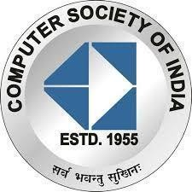**B.R.A.C.T’S**

**Vishwakarma Institute Of Information Technology, Pune**

**Report on: Talk on Competitive Coding**

**Organized by**: Computer Society of India, VIIT Pune Student Branch 2021-2022.

**Date**: 25th September, 2021

Platform: Cisco Webex

**Talk on Competitive Coding**

**25th September, 2021:**

The webinar began exactly at 1:00 pm with a short introduction of the speaker, Mr. Krishna Purohit, and his achievements to the attendees by the anchor of the event Vaishnavi Pophale, joint technical head of CSI-VIIT. She warmly welcomed the speaker and also enlisted the honorable dignitaries who were going to be a part of the webinar. It included Mr.Abhishek Agarwal and Mrs. Snehal Rathi, the chairman and the secretary of CSI Pune Chapter respectively as well as Dr. Sachin Sakhare, Head of Department-COMP, VIIT, Pune and Dr. Vivek Deshpande, Director, VIIT, Pune. Unfortunately, Dr. Sachin Sakhare and Dr. Vivek Deshpande couldn’t join the webinar as they had another important meeting scheduled at that time. Around 150 attendees were present at the beginning of the webinar. The speaker, Mr. Krishna Purohit, started explaining what, exactly, are the necessities for product-based companies like Amazon, Google, WhatsApp, etc. He began explaining the importance of Data Structures and Algorithms concerning WhatsApp, as an example, and further elaborated on it by explaining a few concepts of networking, end-to-end encryption technology in WhatsApp, and how queues are used for storing the messages sent by one user to another before they are received by the other user at the receiver’s end. This is primarily because of the ‘first in, first out’ characteristic of queues. He also explained the usage of other data structures like the stack, dequeue, etc with some other examples and various applications of a few important algorithms like binary search. Thus, he explained how important Data Structures and Algorithms are for WhatsApp as well as for other product-based companies and how Competitive Coding is the best way to master these concepts. He spoke about how competitive coding offers you a good platform to compete with other programmers, improve your coding efficiency and accuracy, upgrade your skillset, and thus excel in coding. He, then, named a few prominent competitive coding websites where students can learn and practice competitive coding. He also showed his progress in competitive coding to the students and spoke on where should their focus be and what should they exactly do at such an early stage in competitive coding. He also described a few must-learn topics in computer engineering. He, then, shared his personal experiences of competitive coding and his overall journey from his engineering times. He spoke about his fields of interest which he used to practice during his engineering times. He advised students to always try their hand in different domains. He insisted on the fact that this is ‘the learning time’ which you, referring to students, will never get again. He concluded his talk with a Q & A session. Students asked many questions and he entertained almost all of them. At students’ request, he spoke about how he got into Amazon through off off-campus placement drive and eventually moved into Microsoft. The webinar was concluded with a vote of thanks by the anchor Vaishnavi Pophale, followed by an address by Mrs. Snehal Rathi to all the attendees.

The poster of the Talk which CSI VIIT Chapter conducted in co-ordination with CSI Pune Chapter

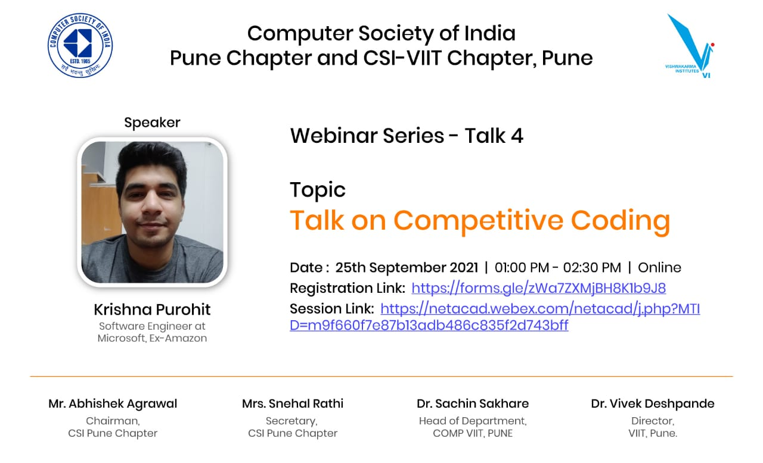

A screenshot of the on-going session with our Speaker, Mr. Krishna Purohit and our Faculty coordinator Mrs. Snehal Rathi as the Host

